

# Chhatrapati Shahu Ji Maharaj University Project Report

On

**E-Book Page Vista**

Submitted in Partial Fulfillment of the Requirements for the Degree of

**Bachelors of Computer Application**

By

**Vishal Prajapati 22015002055**

Under the Supervision of

**[Mentor Name]**



**PSIT College of Higher Education**

**Kanpur-Agra-Delhi National Highway – 2, Bhauti, Kanpur**

**(2024-2025)**

### CERTIFICATE

This is to certify that project entitled “xxxxxxxxxxxxxxxxxxxxxxxxxxx” submitted for partial fulfillment of the degree of BCA under the Department of Bachelor of Computer Application to through PSIT College of Higher Education, Kanpur, done by Mr./Ms._______________________, Roll No. ________________ is an authentic work carried out by me under the guidance of__________________. The matter embodied in this project work has not been submitted earlier for award of any degree or diploma to the best of my knowledge and belief.

### Internal Examiner/Guide External Examiner

### Head of Department

### DECLARATION

I hereby declare that the project entitled “___________________________________________” submitted for the Bachelor of Computer Application degree is my original work and the project has not formed the basis for the award of any other degree of the university or other institute of higher learning, except where due acknowledgment has been made in the text.

Signature of the student

(Name of the Student)

(Roll No)

BCA

PSIT College of Higher Education, Kanpur

**ACKNOWLEDGEMENT**

Presentation inspiration and motivation have always played a key role in the success of any venture.

I express my sincere thanks to Prof. (Dr) Bhagwan Jagwani**, Director PSIT College of Higher Education, Kanpur.**

I pay my deep sense of gratitude to **Dr. Pragati Upadhyay (HOD)** of BCA Department, **PSIT College of Higher Education** to encourage me to the highest peak and to provide me the opportunity to prepare the project. I am immensely obliged to **my friends** for their elevating inspiration, encouraging guidance and kind supervision in the completion of my project.

I feel to acknowledge my indebtedness and deep sense of gratitude to my guide **Mr. /Ms. __________________** whose valuable guidance and kind supervision given to me throughout the course which shaped the present work as its show.

Last, but not the least, **my parents** are also an important inspiration for me. So with due regards, I express my gratitude to them.

**ABSTRACT**

The E-Book Page Vista project is a web-based platform designed to make reading eBooks easier, more enjoyable, and accessible for everyone. As more people turn to digital reading, this project offers a solution that lets users browse, read, and buy eBooks quickly and easily. It combines modern technology with user-friendly features to create a smooth and enjoyable experience for readers.

With E-Book Page Vista, users can explore a large collection of eBooks from various genres, including fiction, non-fiction, and academic books. The platform works on different devices like computers, tablets, and smartphones, ensuring that users can read anytime, anywhere. It’s designed to load quickly and work smoothly, providing an easy-to-use interface that helps readers find what they need without any hassle.

One of the key features is personalized recommendations. The platform suggests books based on the user’s reading history and preferences, making it simple to discover new titles. It also includes interactive tools like adjustable font sizes, different reading modes (light or dark), bookmarks, and a progress tracker to enhance the reading experience.

Security is a top priority. The platform protects user data and ensures safe transactions with trusted payment systems like Razorpay and PayPal. Users can create secure accounts with options like multi-factor authentication to keep their information safe.

The goal of this project is to build a reliable platform that can grow with more users and eBooks over time. It’s designed to handle increasing traffic and data while maintaining fast performance. Future updates may include new features like audiobooks, support for multiple languages, and smarter book recommendations using AI.

In summary, E-Book Page Vista is designed to make digital reading simple, secure, and enjoyable. It provides everything a reader needs in one place—easy browsing, personalized suggestions, secure purchases, and a comfortable reading environment. This project aims to meet the growing demand for digital reading while offering a better, more engaging experience for book lovers everywhere.

**Index/List of Contents consists following Chapters:**

* **Chapter-I:**
* Introduction
* Existing System
* Problems in Existing System
* Proposed System
* Objective of the Project
* **Chapter-II:**
* Modules & Description of the Modules
* System Requirements
* Technology used in project
* **Chapter-III:**
* Feasibility Study
  + - Software Development Life Cycle
    - Data Flow Diagram
* **Chapter-IV:**
* Data Base Schema Design
* Screen/Snap-Shots of the project
* **Conclusion**
* **References**

**Chapter-I**

* **Introduction**

The digital revolution has transformed numerous industries, and the publishing world is no exception. With the advent of eBooks and online reading platforms, the way people consume literature and academic material has undergone a paradigm shift. The shift from physical books to digital formats offers immense convenience, accessibility, and variety, aligning with the fast-paced, technology-driven lifestyles of today.

Despite this progress, several challenges persist in existing eBook platforms, such as limited functionalities, accessibility issues, and lack of personalization. Addressing these shortcomings, the **E-Book Page Vista** project is designed to be a next-generation web-based application that combines user-friendliness, scalability, and innovative features to deliver a superior digital reading experience.

This project aspires to provide a robust platform that goes beyond merely offering eBooks for download. It includes personalized book recommendations, secure purchasing mechanisms, and an intuitive, interactive interface that enhances the joy of reading. By catering to both leisure readers and academic users, **E-Book Page Vista** aims to establish itself as a versatile and comprehensive digital library for the modern reader.

* **Existing System**

Over the years, several eBook platforms have entered the market, each offering unique features to attract users. However, a detailed analysis of the current landscape reveals significant limitations that hinder user satisfaction and platform growth.

1. **Fragmented Services**:  
   Many platforms offer fragmented services, where browsing, purchasing, and reading are separate processes. Users often switch between applications or websites to perform these tasks, creating a disjointed experience.
2. **Minimal Customization**:  
   Existing platforms typically fail to prioritize user experience. They lack advanced customization options such as adjustable themes, font sizes, or interactive tools that cater to individual reading preferences.
3. **Lack of Security**:  
   With rising concerns over data privacy, many eBook platforms fall short in providing secure environments for transactions and user data. This can result in a lack of trust among users.
4. **Device Dependency**:  
   Some platforms are not optimized for multiple devices, restricting accessibility. Non-responsive designs make it challenging for users to enjoy eBooks on various screen sizes.
5. **Inadequate Catalog Organization**:  
   Poorly designed search mechanisms and limited filtering options make it cumbersome for users to find relevant books efficiently.

* **Problems in Existing System**

The challenges posed by current systems result in several pain points for users:

1. **Inefficient Discovery**:  
   Users often struggle to find books that match their interests, leading to frustration and time wastage. The lack of intelligent search and recommendation systems exacerbates this issue.
2. **Fragmented Ecosystem**:  
   Most platforms lack an integrated approach, where users can seamlessly discover, read, and purchase books within the same system.
3. **Security Concerns**:  
   Users frequently encounter security issues such as data breaches or unreliable payment systems, which reduce trust in the platform.
4. **Performance and Scalability Issues**:  
   Platforms with outdated architectures fail to handle increasing user traffic and larger content libraries, resulting in poor performance.
5. **Inaccessibility for Diverse Audiences**:  
   Current systems often lack support for multiple languages, genres, or accessibility features for users with disabilities.

* **Proposed System**

The **E-Book Page Vista** project is designed as a comprehensive solution to address the limitations of current systems. By integrating cutting-edge technologies and user-centric design principles, it offers a seamless, secure, and feature-rich digital reading experience.

Key features of the proposed system include:

1. **Unified Platform**:  
   A single platform where users can browse, read, and purchase eBooks, eliminating the need for multiple tools or applications.
2. **Enhanced User Experience**:  
   The system offers customizable reading options, including adjustable themes, font sizes, and bookmarking tools. These features ensure users can tailor their reading environment to their preferences.
3. **Personalized Recommendations**:  
   Advanced algorithms analyze user behavior and preferences to suggest books that align with their interests, ensuring a more engaging experience.
4. **Secure and Reliable Transactions**:  
   Integration with secure payment gateways such as Razorpay or PayPal ensures that users can make purchases confidently without concerns over data breaches or fraud.
5. **Device Independence**:  
   A fully responsive design guarantees that the platform works seamlessly across desktops, tablets, and smartphones, enhancing accessibility.
6. **Scalable Backend Infrastructure**:  
   The platform’s architecture is built to handle a growing user base and expanding eBook catalog without compromising performance.

* **Objective of the Project**

The objectives of the **E-Book Page Vista** project are ambitious yet practical, focusing on addressing the diverse needs of eBook readers. These include:

1. **Designing a Comprehensive Platform**:  
   Developing a user-friendly web-based system where users can browse, read, and purchase eBooks without switching between applications.
2. **Enhancing Reader Experience**:  
   Providing interactive tools, such as reading progress trackers and multi-language support, to cater to diverse user groups, including students, professionals, and casual readers.
3. **Ensuring Security and Privacy**:  
   Implementing robust data protection measures and reliable payment systems to build trust among users.
4. **Promoting Inclusivity**:  
   Curating a library with books in various genres, languages, and accessibility options to serve a broad audience, including those with special needs.
5. **Future-Ready Architecture**:  
   Leveraging scalable backend technologies to ensure the platform can adapt to emerging trends, such as audiobooks, AI-driven content curation, and real-time analytics.

By integrating these objectives, **E-Book Page Vista** aims to bridge the gaps in the current eBook ecosystem and redefine the digital reading experience. It is not merely a project but a visionary step toward making quality literature and academic content accessible to everyone, anytime, anywhere.

**Chapter-II**

* **Modules & Description of the Modules**

The **E-Book Page Vista** project has been designed with modularity in mind, dividing its functionality into distinct modules to ensure seamless performance, flexibility, and scalability. Each module is responsible for addressing a specific aspect of the platform's operations, contributing to the overall user experience.

**1. User Authentication and Profile Management**

* **Purpose**: To provide secure access and a personalized experience for users.
* **Features**:
  + **User Registration**: New users can create accounts with unique credentials, including email verification for added security.
  + **Login and Logout**: Ensures a smooth user login experience with multi-factor authentication options to enhance security.
  + **Profile Management**: Users can update their profile details, such as preferences, display names, and saved payment methods.
  + **Password Recovery**: Features like password reset through email links or security questions ensure account recovery without compromising security.
* **Benefits**: This module fosters trust and personalization, ensuring users feel secure and valued while interacting with the platform.

**2. eBook Catalog and Search**

* **Purpose**: To create a comprehensive and easily navigable library of eBooks.
* **Features**:
  + **Categorization**: eBooks are categorized by genres, authors, languages, and publication years, ensuring an organized collection.
  + **Advanced Search**: Users can search by title, keywords, or ISBN and filter results by ratings, price range, or availability.
  + **Book Previews**: Allows users to view sample pages or summaries before purchase.
  + **User Reviews and Ratings**: Enables readers to leave reviews and ratings, enhancing the decision-making process for others.
* **Benefits**: This module ensures that users can find books quickly and efficiently, with detailed information to guide their choices.

**3. Interactive Reading Tools**

* **Purpose**: To make the reading process enjoyable, interactive, and accessible.
* **Features**:
  + **Adjustable Reading Modes**: Offers light, dark, and sepia themes to reduce eye strain in different lighting conditions.
  + **Customizable Font Options**: Users can adjust font size, type, and spacing for a personalized reading experience.
  + **Bookmarking and Annotation**: Readers can save pages or add notes to specific sections, enhancing engagement and usability.
  + **Reading Progress Tracker**: Automatically tracks how much of the book has been read and syncs progress across devices.
  + **Accessibility Features**: Includes support for text-to-speech, high-contrast modes, and keyboard navigation for visually impaired users.
* **Benefits**: This module not only improves the reading experience but also ensures inclusivity for a wider range of users.

**4. Payment Integration and Order History**

* **Purpose**: To provide a secure and transparent mechanism for purchasing eBooks.
* **Features**:
  + **Payment Gateways**: Integration with trusted platforms such as Razorpay, PayPal, or Stripe ensures secure transactions.
  + **Multiple Payment Options**: Supports credit cards, debit cards, digital wallets, and UPI for user convenience.
  + **Order History**: Maintains detailed purchase records, including receipts and download links for past purchases.
  + **Refund and Cancellation Policies**: Enables users to request refunds or cancellations under defined terms.
* **Benefits**: By prioritizing user security and providing detailed order management, this module builds trust and reliability.
* **System Requirements**

The success of the **E-Book Page Vista** project depends on meeting specific software and hardware requirements to ensure smooth operation and compatibility across various environments.

**1. Software Requirements**

* **Operating System Compatibility**:
  + Works seamlessly on Windows, Linux, and macOS for developers and end-users.
* **Development Tools**:
  + **Visual Studio Code**: For writing and debugging the application code.
  + **Node.js**: As a runtime environment for server-side programming.
  + **Git**: For version control and collaborative development.
  + **Postman**: To test and debug REST APIs.
  + **Figma**: For creating UI/UX designs.
* **Browser Support**:
  + Compatible with Chrome, Firefox, Safari, and Edge, ensuring a smooth experience for end-users across all popular browsers.

**2. Hardware Requirements**

* **Processor**:
  + Development: Intel Core i5 or higher.
  + End-Users: Dual-core processor or higher.
* **RAM**:
  + Development: Minimum 8 GB for efficient coding and testing.
  + End-Users: 4 GB for standard operations.
* **Storage**:
  + At least 100 GB is necessary for managing the database, eBook files, and multimedia resources.
* **Network**:
  + A stable, high-speed internet connection for seamless browsing, downloads, and updates.
* **Technology Used in the Project**

**1. Frontend Technologies**

* **HTML5 and CSS3**: For structuring and styling the web pages, ensuring a visually appealing interface.
* **JavaScript**: Enables dynamic interactivity, such as animations and real-time updates.
* **Bootstrap**: Simplifies responsive design, ensuring the platform looks great on all devices.
* **Optional Libraries**: React or jQuery may be used for additional interactivity and performance enhancements.

**2. Backend Technologies**

* **Node.js**: A lightweight, efficient runtime environment for server-side programming.
* **Express.js**: A flexible framework for building APIs and handling backend operations.

**3. Database Technologies**

* **MongoDB**: A NoSQL database for managing user profiles, reading preferences, and catalog metadata.
* **MySQL**: A relational database for structured data, including order records and payment transactions.

**4. Frameworks and Tools**

* **RESTful APIs**: Facilitates communication between the frontend and backend, enabling a seamless user experience.
* **Payment APIs**: Integration with secure gateways like Razorpay or PayPal for transaction processing.
* **UI/UX Design Tools**: Figma ensures the creation of intuitive and user-friendly interfaces.

**5. Application Architecture**

The platform is built using a three-tier architecture:

* **Presentation Layer**:
  + Manages user interaction through the frontend interface.
* **Application Layer**:
  + Handles business logic, such as user authentication and API interactions.
* **Data Layer**:
  + Manages the storage and retrieval of user data, eBook catalogs, and transaction details.

**6. Development Tools and Testing**

* **Postman**: To test API endpoints for reliability and performance.
* **Version Control with Git**: Ensures code integrity and collaborative development.
* **Unit Testing Frameworks**: Tools like Mocha or Chai are used for testing backend functionality.

By combining these technologies and requirements, **E-Book Page Vista** ensures a robust, secure, and user-centric solution for modern readers.

**Chapter-III**

* **Feasibility Study**

A feasibility study assesses the viability of the **E-Book Page Vista** project from various perspectives, ensuring that the proposed system is practical, achievable, and sustainable. It evaluates the project based on technical, economic, and operational criteria.

**1. Technical Feasibility**

Technical feasibility examines whether the required technology and tools are available and capable of supporting the system’s development and deployment.

* **Available Technologies**:  
  The project leverages widely used and well-supported technologies such as Node.js, MongoDB, HTML5, CSS3, and Bootstrap. These tools are robust, scalable, and suitable for web-based applications.
* **Infrastructure Readiness**:  
  Both development and deployment can be handled on standard hardware configurations, ensuring compatibility with various devices and platforms.
* **Development Expertise**:  
  The team possesses the technical skills needed to design, implement, and maintain the system, ensuring smooth execution.

**2. Economic Feasibility**

Economic feasibility focuses on determining whether the project is financially viable.

* **Initial Investment**:  
  Development costs are relatively low due to the use of open-source technologies like Node.js and MongoDB.
* **Operational Costs**:  
  Ongoing costs, such as server maintenance and updates, are manageable within the projected budget.
* **Return on Investment (ROI)**:  
  With features like secure transactions and personalized recommendations, the platform is expected to attract a broad user base, ensuring steady revenue through eBook sales and subscriptions.

**3. Operational Feasibility**

Operational feasibility evaluates whether the proposed system meets user requirements and fits into existing workflows.

* **User-Friendly Design**:  
  Intuitive navigation and customizable reading tools ensure a smooth user experience for both novice and advanced users.
* **Stakeholder Satisfaction**:  
  Authors, publishers, and readers benefit from the platform, making it a win-win solution for all parties.
* **Future Scalability**:  
  The system is designed to handle increasing user traffic and a growing catalog of eBooks, ensuring long-term sustainability.

By addressing these feasibility criteria, the **E-Book Page Vista** project demonstrates its capability to deliver a technically sound, economically viable, and operationally efficient solution.

* **Software Development Life Cycle (SDLC)**

The development of **E-Book Page Vista** follows the Software Development Life Cycle (SDLC), a systematic process to ensure high-quality software delivery. The SDLC model chosen for this project is the **Agile Model**, which emphasizes iterative development and continuous feedback.

**1. Requirements Gathering and Analysis**

* **Objective**:  
  Identify and document user needs, system requirements, and constraints.
* **Activities**:
  + Conducted surveys and interviews with potential users to understand their expectations.
  + Created a detailed requirement specification document outlining the features, functionality, and technical specifications.

**2. Design**

* **Objective**:  
  Create a blueprint for the system, including architecture, database schema, and UI/UX design.
* **Activities**:
  + Developed wireframes and prototypes using Figma.
  + Designed a three-tier architecture with presentation, application, and data layers.
  + Created a data model for managing eBook metadata, user profiles, and transaction history.

**3. Implementation**

* **Objective**:  
  Translate design into code and integrate system components.
* **Activities**:
  + Frontend development using HTML5, CSS3, and JavaScript.
  + Backend logic implementation with Node.js and Express.js.
  + Database integration using MongoDB for flexible storage and MySQL for structured data.

**4. Testing**

* **Objective**:  
  Identify and fix defects to ensure a bug-free application.
* **Activities**:
  + Performed unit testing of modules using tools like Mocha and Chai.
  + Conducted integration testing to ensure seamless interaction between frontend and backend.
  + Conducted user acceptance testing (UAT) to validate the system with real-world scenarios.

**5. Deployment**

* **Objective**:  
  Launch the system for user access.
* **Activities**:
  + Deployed the application on a secure web server.
  + Configured domain and SSL certificates for secure transactions.

**6. Maintenance and Updates**

* **Objective**:  
  Ensure long-term system performance and introduce new features.
* **Activities**:
  + Monitored system performance using analytics tools.
  + Released updates based on user feedback and emerging trends in digital reading.
* **Data Flow Diagram (DFD)**

The Data Flow Diagram (DFD) provides a graphical representation of the data flow within the **E-Book Page Vista** platform. It illustrates how data is processed and transferred between various components of the system.

**Level 0: Context Diagram**

At the highest level, the context diagram shows the interaction between the **E-Book Page Vista** system and external entities.

* **Entities**:
  + Users: Register, log in, and interact with the platform.
  + Payment Gateway: Handles transaction processing.
  + Database: Stores user profiles, eBook metadata, and purchase history.
* **Processes**:
  + User registration and login.
  + Browsing and searching the eBook catalog.
  + Purchasing eBooks and viewing order history.

**Level 1: Detailed DFD**

The Level 1 DFD breaks down the system into specific processes:

1. **User Authentication**:
   * Input: User credentials (email, password).
   * Process: Verify credentials against stored data.
   * Output: Grant or deny access.
2. **eBook Browsing and Search**:
   * Input: User search queries or browsing actions.
   * Process: Retrieve relevant eBooks based on filters and keywords.
   * Output: Display search results or recommendations.
3. **Interactive Reading Tools**:
   * Input: User-selected preferences (font size, theme, bookmarks).
   * Process: Apply customizations to the reading interface.
   * Output: Personalized reading experience.
4. **Payment Processing**:
   * Input: User payment details.
   * Process: Forward data to the payment gateway for validation.
   * Output: Confirm transaction and generate order receipt.
5. **Order Management**:
   * Input: User purchase details.
   * Process: Update order history and generate download links.
   * Output: Provide access to purchased eBooks.

**Level 2: Expanded DFD**

For larger subsystems, the Level 2 DFD provides further detail. For example:

* **User Profile Management**:
  + Update personal details.
  + View and edit saved eBook preferences.
* **Recommendation Engine**:
  + Analyze user history and preferences.
  + Generate dynamic recommendations based on AI algorithms.

By visually representing these processes, the DFD ensures a clear understanding of how data flows within the system, aiding both developers and stakeholders in comprehending the system’s functionality.

**Chapter-IV**

* **Database Schema Design**

The database schema design is the backbone of the **E-Book Page Vista** project, organizing data in a structured manner to ensure efficient storage, retrieval, and management. The schema employs a combination of NoSQL (MongoDB) for flexible data storage and SQL (MySQL) for relational data, balancing performance with scalability.

**Database Tables and Collections**

The system’s data is divided into multiple entities to handle users, eBooks, transactions, and more.

**1. Users Table/Collection**

* **Purpose**: To store user information and manage authentication.
* **Fields**:
  + UserID (Primary Key): Unique identifier for each user.
  + Name: Full name of the user.
  + Email: User email address, used for login and notifications.
  + Password: Hashed password for secure authentication.
  + Preferences: User preferences for genres, themes, or languages.
  + CreatedAt: Timestamp of account creation.
  + UpdatedAt: Timestamp of the last profile update.

**2. eBooks Table/Collection**

* **Purpose**: To manage information about the eBooks available on the platform.
* **Fields**:
  + BookID (Primary Key): Unique identifier for each eBook.
  + Title: Name of the book.
  + Author: Author of the book.
  + Genre: Genre or category of the book.
  + Language: Language of the book.
  + Price: Cost of the book for purchase.
  + Stock: Number of copies available.
  + FilePath: Path to the eBook file for download.
  + Description: A summary or synopsis of the book.
  + UploadedAt: Timestamp of the book upload.

**3. Transactions Table/Collection**

* **Purpose**: To record purchases and maintain order history.
* **Fields**:
  + TransactionID (Primary Key): Unique identifier for each transaction.
  + UserID (Foreign Key): Links to the Users table.
  + BookID (Foreign Key): Links to the eBooks table.
  + Amount: Total amount paid for the transaction.
  + PaymentStatus: Status of the payment (e.g., Success, Pending).
  + TransactionDate: Timestamp of the transaction.

**4. Reviews and Ratings Table/Collection**

* **Purpose**: To store user reviews and ratings for books.
* **Fields**:
  + ReviewID (Primary Key): Unique identifier for each review.
  + BookID (Foreign Key): Links to the eBooks table.
  + UserID (Foreign Key): Links to the Users table.
  + Rating: Numeric rating (e.g., 1–5 stars).
  + ReviewText: Textual feedback provided by the user.
  + CreatedAt: Timestamp of the review submission.

**5. Recommendations Table/Collection (Optional)**

* **Purpose**: To store personalized recommendations generated by the system.
* **Fields**:
  + RecommendationID: Unique identifier for each recommendation.
  + UserID: Links to the Users table.
  + RecommendedBooks: Array of BookIDs based on user preferences.

**Database Relationships**

* **One-to-Many**:
  + A user can make multiple transactions, and each transaction may include multiple books.
* **Many-to-Many**:
  + Users can leave multiple reviews, and books can have multiple reviews from different users.
* **Parent-Child**:
  + Transactions are child records linked to both users and books.

**Database Design Diagram**

Below is a description of the database design layout (to be represented visually in tools like ER diagrams):

* **Users** are linked to **Transactions**, which in turn are linked to **eBooks**.
* **Reviews** form a secondary relationship between users and eBooks.

This schema ensures that data redundancy is minimized while optimizing access times for user queries and transactions.

**Screen/Snapshots of the Project**

The following section highlights the key interfaces of the **E-Book Page Vista** platform. Each screen is designed for ease of use, interactivity, and responsiveness.

**1. User Registration and Login Page**

* **Description**:
  + The landing page allows users to either register or log in.
  + Features a clean interface with input fields for email and password.
  + Includes options for password recovery and multi-factor authentication.
* **Key Features**:
  + Validation for empty fields, invalid formats, and weak passwords.
  + Error messages displayed in real-time to enhance usability.

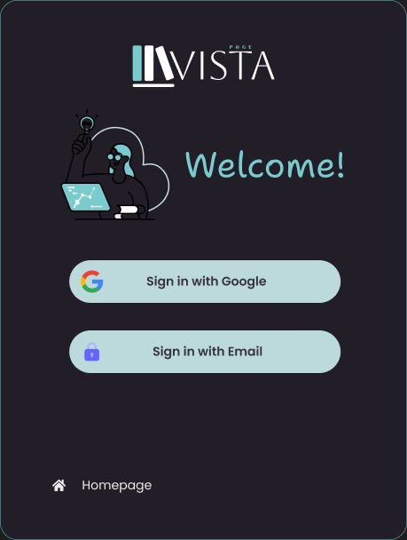

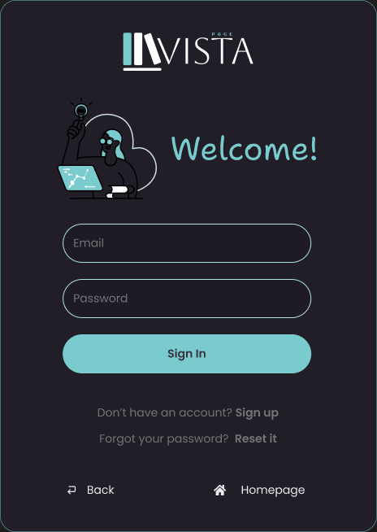

**2. eBook Catalog**

* **Description**:
  + Displays a categorized and searchable list of eBooks.
  + Features filters for genres, authors, ratings, and price ranges.
  + Each book listing includes a cover image, title, author, and a "Preview/Buy" button.
* **Key Features**:
  + Dynamic updates based on user input in the search bar or filters.
  + Pagination or infinite scroll for large catalogs.

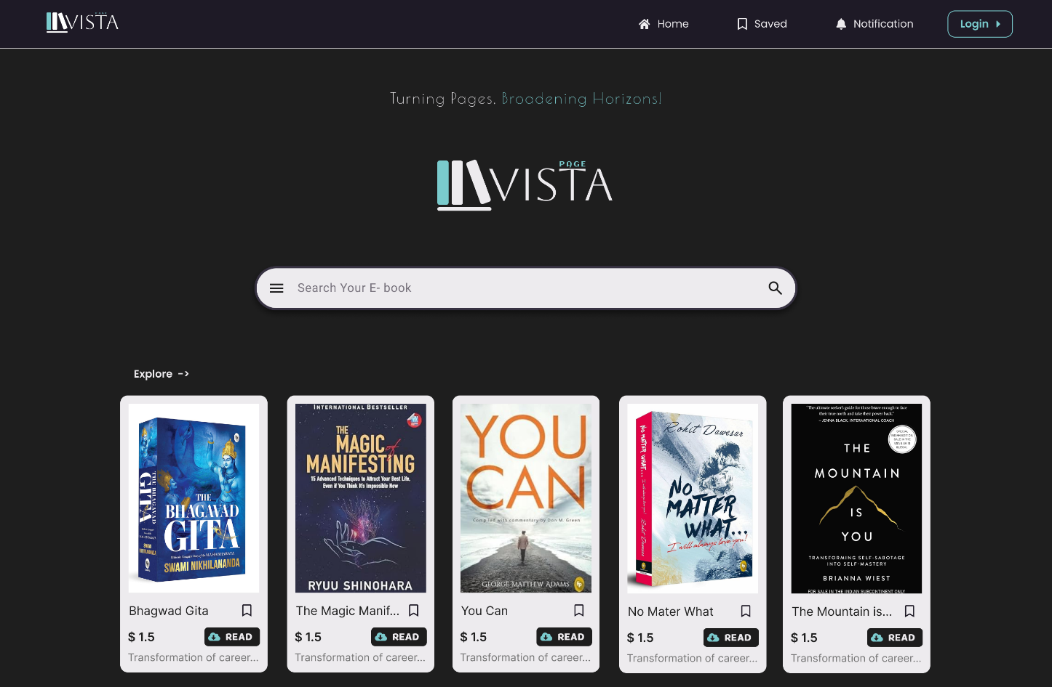**3. Book Details Page**

* **Description**:
  + A detailed page for individual books, including title, author, synopsis, price, and user reviews.
  + Offers options to preview the book or proceed to purchase.
* **Key Features**:
  + Star ratings and textual reviews submitted by other users.
  + Recommendations for similar books displayed at the bottom.



**4. Interactive Reader Page**

* **Description**:
  + Provides an immersive reading environment for purchased books.
  + Includes customizable settings such as font size, reading modes, and bookmark placement.
* **Key Features**:
  + Adjustable reading themes (light, dark, sepia).
  + Progress bar showing percentage completed.
  + Text-to-speech functionality for an accessible reading experience.

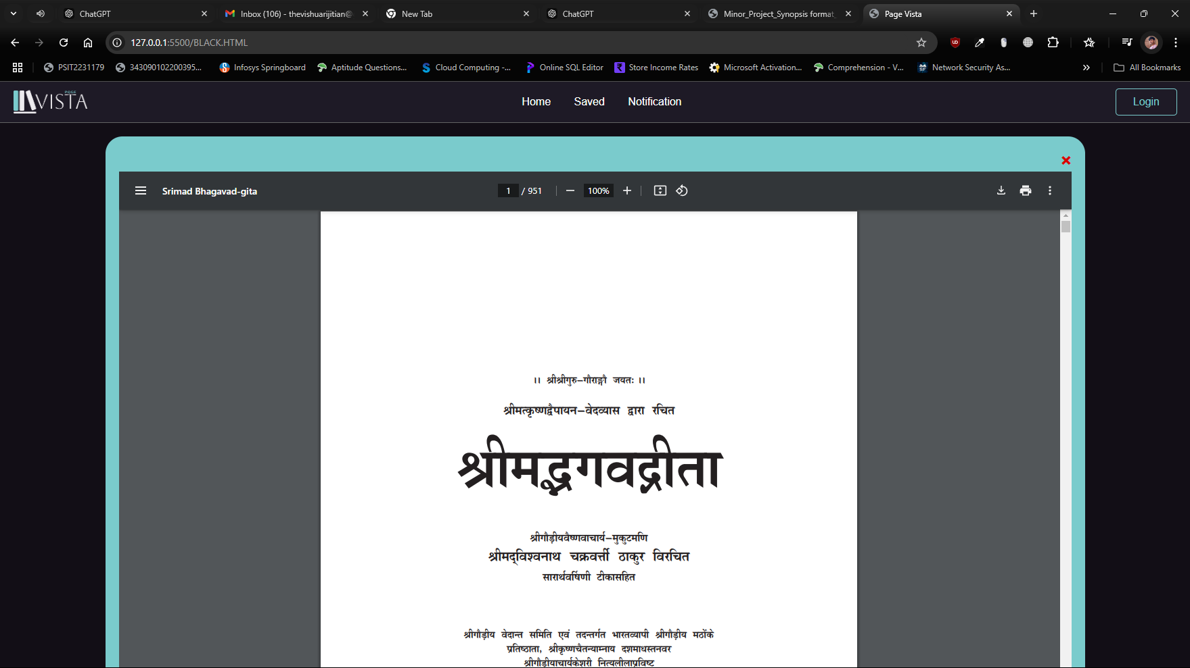

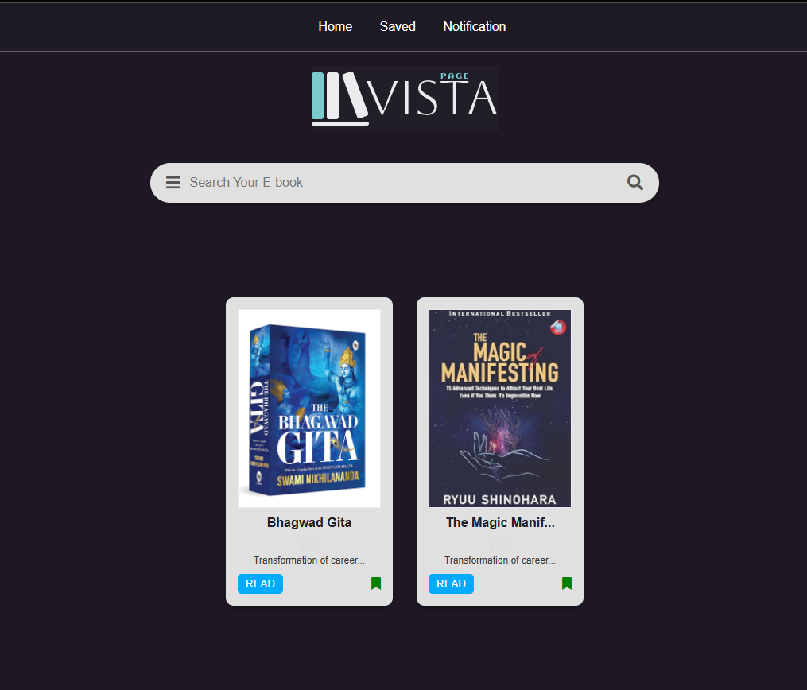

**5. Payment Gateway**

* **Description**:
  + Secure payment page integrated with gateways like Razorpay or PayPal.
  + Includes options for UPI, credit cards, debit cards, and wallets.
* **Key Features**:
  + Displays order summary with a breakdown of prices.
  + Provides real-time transaction updates (e.g., “Payment Processing” or “Success”).

**6. Order History Page**

* **Description**:
  + Allows users to view their past transactions and download purchased books.
  + Includes detailed information such as book title, purchase date, and transaction ID.
* **Key Features**:
  + Sorting options by date, book name, or amount spent.
  + Resend email receipts or download invoices directly.

**7. Admin Dashboard (Optional)**

* **Description**:
  + A backend interface for administrators to manage users, books, and transactions.
  + Provides analytics on user activity, sales, and book popularity.
* **Key Features**:
  + Ability to add/edit/remove books or user accounts.
  + Visual reports on sales trends, user registrations, and ratings.

These interfaces and schema designs form the core of the **E-Book Page Vista** platform, ensuring a cohesive user experience and robust data management. Screenshots (mock-ups or actual project images) can be added later to visually demonstrate these features.

**Conclusion**

The **E-Book Page Vista** project has been designed to offer a comprehensive, feature-rich platform that caters to the growing demand for digital reading. By addressing key limitations found in existing eBook systems—such as fragmented services, limited customization, and security concerns—this platform aims to provide a seamless and user-friendly experience for eBook enthusiasts.

The project successfully integrates various technologies and best practices to ensure a smooth and interactive reading environment. The modular approach to system design, coupled with a well-organized database schema, ensures the platform can efficiently handle a growing user base, an expanding catalog of eBooks, and secure transactions. The user interface, built with accessibility in mind, provides intuitive navigation, customizable reading tools, and real-time personalized recommendations.

Moreover, the use of modern web technologies like Node.js, MongoDB, and responsive front-end frameworks ensures that the platform is scalable, fast, and adaptable to the ever-changing needs of its users. By offering a unified platform for browsing, reading, and purchasing eBooks, **E-Book Page Vista** stands to redefine the digital reading experience.

Looking forward, the platform can be expanded to include additional features such as multilingual support, audiobooks, and artificial intelligence-driven content curation. These enhancements would further enhance user engagement and ensure the platform's long-term success in the competitive digital reading market.

In conclusion, **E-Book Page Vista** aims to become a reliable and innovative solution for book lovers, providing them with an efficient and enjoyable digital reading experience that is secure, scalable, and accessible.

**References**

1. **Node.js Documentation**  
   Node.js Foundation. (n.d.). Retrieved from <https://nodejs.org/>
2. **MongoDB Documentation**  
   MongoDB, Inc. (n.d.). Retrieved from [https://www.mongodb.com](https://www.mongodb.com/)
3. **MDN Web Docs**  
   Mozilla Developer Network. (n.d.). Retrieved from [https://developer.mozilla.org](https://developer.mozilla.org/)
4. **Bootstrap Framework**  
   Bootstrap. (n.d.). Retrieved from [https://getbootstrap.com](https://getbootstrap.com/)
5. **Razorpay API Documentation**  
   Razorpay. (n.d.). Retrieved from [https://razorpay.com](https://razorpay.com/)
6. **PayPal API Documentation**  
   PayPal, Inc. (n.d.). Retrieved from [https://developer.paypal.com](https://developer.paypal.com/)
7. **Express.js Documentation**  
   Express.js. (n.d.). Retrieved from [https://expressjs.com](https://expressjs.com/)
8. **Figma Design Tool**  
   Figma, Inc. (n.d.). Retrieved from [https://www.figma.com](https://www.figma.com/)
9. **W3Schools HTML5 Tutorial**  
   W3Schools. (n.d.). Retrieved from <https://www.w3schools.com/html/>
10. **JavaScript - MDN Web Docs**  
    Mozilla. (n.d.). Retrieved from <https://developer.mozilla.org/en-US/docs/Web/JavaScript>

These sections wrap up the project documentation and provide a clear path for understanding the development and execution of the **E-Book Page Vista** platform, as well as providing resources for future learning or reference.